Sailing Instructions

Swedish International Moth Championship
GKSS Skiffregatta Waszp

Dates: 2022, September 16th -18th
Location: GKSS, Gothenburg
Boat classes: : Moth Open, Waszp Open

1. Race office and Signal pole
1.1 Race office is located in GKSS club house.

1.2 Signals made ashore will be displayed on the flag pole marked with an orange flag next to the berthing ramp.

1.3 When flag AP is displayed ashore, ’1 minute’ is replaced with ’not less than 60 minutes’ in RRS Race Signals.

1.4 Flag D displayed on the flage pole together with one sound signal means the boats are allowed to leave the harbour. If flag D is not displayed, the boats shall stay ashore.

1.5 Each competitor shall wear a personal flotation device except briefly while changing or adjusting clothing or personal equipment when flag Y is displayed on the flag pole or on the starting vessel, according to RRS 40.1. A boat breaking this rule may be warned or penalized at the discretion of the protest committee.

2. Schedule

2.1 Friday 16th September
15:00 The Regatta Office opens
16:00 Skippers briefing
17:00 First warning signal, Tune up Slalom Racing (4 races)
BBQ After Sail

The tune up race course used on Friday, September the 16th will be a Grand Prix course, which is described in Appendix A of this Sailing Instruction

Saturday 17th September
13:25 First warning signal, Championship Racing (4 races)
After Sail ASAP after racing

Sunday 18th September
11:00 First warning signal, Championship Racing (4 races)
Prizegiving ASAP after racing

2.2 No warning signal will be made after 15:00 on Sunday the 18th.

3 Marks

3.1 The startmark will be the RC boat with an orange flag.
The gate marks are yellow cylinders.
The finish mark will be the RC boat with a blue flag.

3.2 Upon a change of a leg, the the first mark will be moved to its new position (see 6.5 for procedure).

4 Course

4.1 The Course (see sketch below) shall be sailed:
START – 1A/1B (Gate) – 2A/2B (Gate) – 1A/1B (Gate) – FINISH (between RC and 2B).

4.2 If, Flag T (RED/WHITE/BLUE) is displayed, no later than together with the Warning signal an extra lap is added. The Course shall then be sailed:
START – 1A/1B (Gate) – 2A/2B (Gate) – 1A/1B (Gate) – 2A/2B (Gate) – 1A/1B (Gate) – FINISH (between RC and 2B).

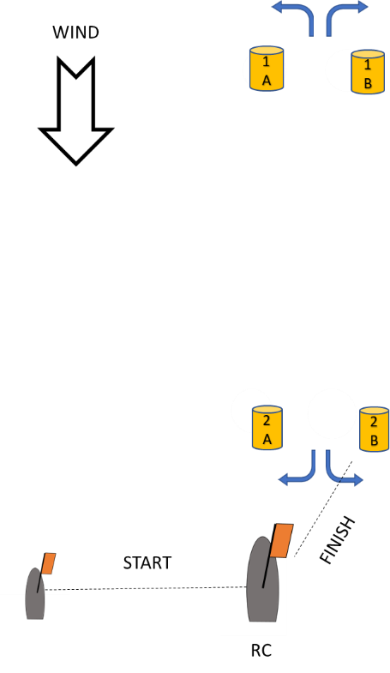

4.3 A lapsed finish procedure may be used, as described in Appendix B of this Sailing Instruction. When the lapsed finish procedure is used, this procedure will be applied jointly for Moth Open and Waszp Open in a common finish procedure.

4.4 The racing area is restricted for competitors as described in Appendix C.

5 Time limits
5.1 The race time limit is 40 min
5.2 The finishing window is 20 min.

6. Changes and additions to appendix S
6.1 To alert boats that a new starting sequence is about to begin, the orange flag on the starting line will be displayed with a sound signal not less than two minutes before the warning signal. This changes Appenix S 5.2.

6.2 The races shall be started following a three minutes starting procedure as described in the table below. This changes Appendix S 9.1.

Minutes before starting signal | Visual signal | Sound signal | Means
3 | Class flag | One | Warning signal
2 | P, I, U, black flag | One | Preparatory signal
1 | Preparatory flag removed | One long | One minute
0 | Class flag removed | One | Start signal

6.3 The class flag will be Flag E (Blue and Red) jointly for Moth Open and Waszp Open. This changes Appendix S 6.1

6.4 The start line is between the orange flags displayed on the starboard end race commite vessel (RC) and the port end flag boat. This changes Appendix S 9.2

6.5 The finish line is between the blue flag displayed on the race commite vessel (RC) and mark 2B. This changes Appendix S 9.2

6.6 A boat that does not start within five minutes after her starting signal will be scored Did Not Start (DNS) without a hearing. This changes RRS A5.1 and A5.2

6.7 RRS 33 is changed to:
While boats are racing, the race committee may change a leg of the course.

Signal flag C together with repetitive sounds is a sufficient signal when changing position of the new mark. This changes RRS 33.

6.8 RRS appendix P will apply.

6.9 RRS 44.1 and RRS P2.1 are changed so that the Two-Turns penalty is replaced by a One-Turn penalty.

6.10 RRS appendix T will apply.

Date of issue: 2022-09-14

Appendix A Desription of the Grand Prix tune-up course for September the 16th

Marks
The startmark and finish mark will both be the race commite boat with an orange flag.
The Reach Mark will be a red conical mark.
The Windward and Leeward gates will be yellow cylindrical marks.

Course
The Course (see sketch below) shall be sailed:
START – R (Reach Mark) – 1A/1B (Leeward Gate) – 2A/2B (Windward Gate) – 1A/1B (Leeward Gate) – R (Reach Mark) – FINISH

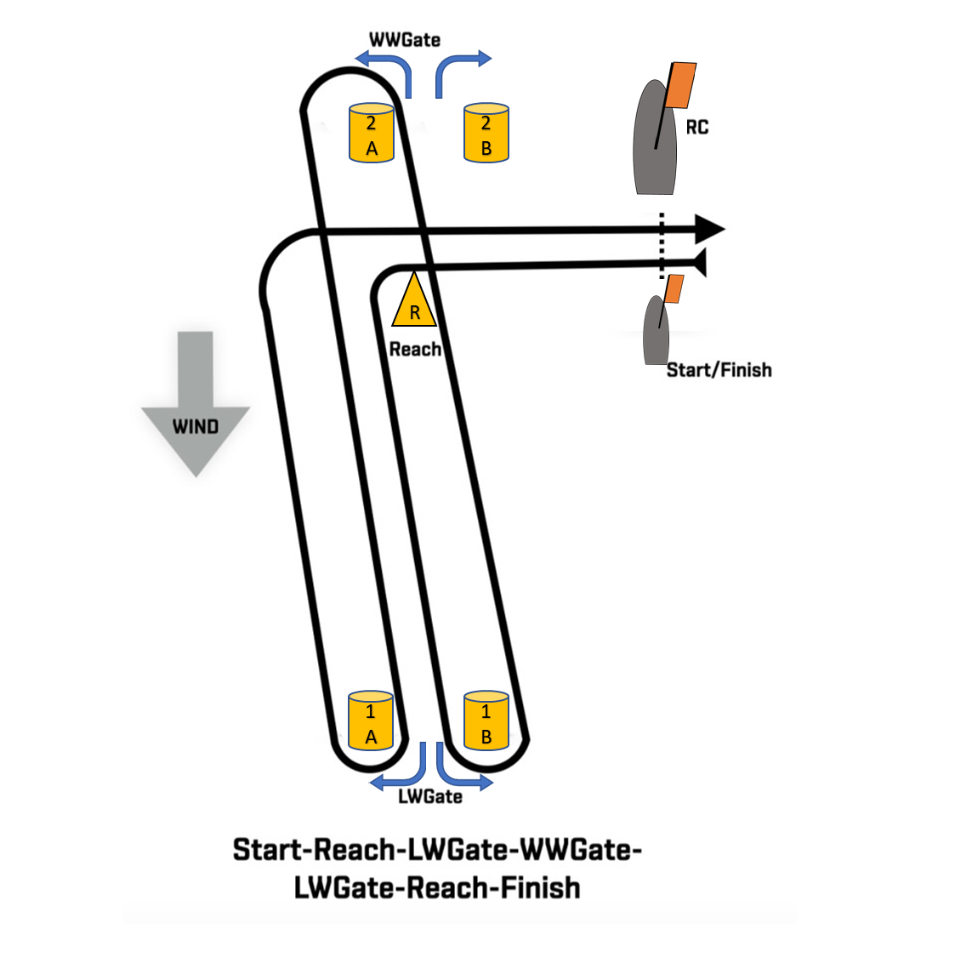

Start line and finish line
The start line and the finish line are both between the orange flags displayed on the windward race committee start vessel and the leeward flag boat.

Scoring
The ‘Grand Prix’ (Lapsed Finish) procedure will be used.

Racing area restriction
The racing area is restricted for competitors as described in Appendix C

Appendix B Desription of the Lapsed Finish procedure

When the leading boat completes the course and finishes, the Race Committee signal boat will immidiately display a green and white chequered flag with a sound signal. This indicates the Finishing Time Window is now open. From this time, all boats shall cross the finishing line. All boats that cross the finishing line within 20 minutes after the leading boat has finished, shall be deemed to be finished irrespective of number of laps they have completed. Their position in the race will be noted from their finishing order and number of completed laps, with those having the most laps being recorded ahead of those with less completed laps. Boats that have completed 1 lap shall be ranked behind boats that have completed 2 laps. Boats that have completed 2 laps shall be ranked behind boats that have completed 3 laps. If a boat after the Finishing Time Window has opened sails one more lap, this will not count as a completed lap in the scoring. This changes RRS 28.1 and A4.

Boats failing to cross the finish line within the Finishing Time Window, will be scored after those finishing as described in the above mentioned finishing rule. They will be scored according to their position at the previous passing of the gate or bottom mark. If they have not been able to complete one lap, the will be scored did Not Finish without a hearing. This changes RRS 35, A4 and A5.

Appendix C Racing area restriction

The racing are is restricted by a line between the south est end of Stockholmarna (“Stockh”) and the cardinal mark (Black-Yellow-Black) South east of Stokholmarna, the line is marked as a red line in the chart bellow. The line may not be crossed during racing. The reason for the restriction is shallow water between Stockholmarna and the cardinal mark.

