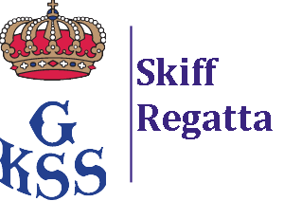

Sailing Instruction (SI), Change 2

Swedish International Moth Championship GKSS 2022
And Skiffregatta for Waszp

Changed paragraphs:

4.2 If, Flag T (RED/WHITE/BLUE) is displayed, no later than together with the Warning signal an extra lap is added for the Moth open class. The Course shall then be sailed:
START – 1A/1B (Gate) – 2A/2B (Gate) – 1A/1B (Gate) – 2A/2B (Gate) – 1A/1B (Gate) – FINISH (between RC and 2B).

5.2 The finishing window is 10 min, counted separately for the Moth Open and Waszp Open classes.

Date: 2022-09-17

