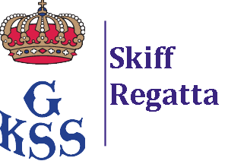

Sailing Instruction (SI), Change 1

Swedish International Moth Championship GKSS 2022
And Skiffregatta for Waszp

Changed paragraphs:

Appendix A

Course
The Course (see sketch below) shall be sailed:
START – R (Reach Mark) – 1A/1B (Leeward Gate) – 2A/2B (Windward Gate) – 1A/1B (Leeward Gate) – R (Reach Mark) – FINISH

If, Flag T (RED/WHITE/BLUE) is displayed, no later than together with the Warning signal an extra lap is added. The Course shall then be sailed: START – R (Reach Mark) – 1A/1B (Leeward Gate) – 2A/2B (Windward Gate) – 1A/1B (Leeward Gate) – 2A/2B (Windward Gate) – 1A/1B (Leeward Gate) R (Reach Mark) – FINISH

Scoring
The ‘Grand Prix’ (Lapsed Finish) procedure may be used.

Date: 2022-09-16

