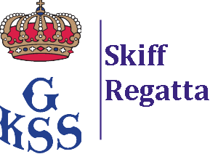

Notice of Race (NoR), Change 1

Swedish International Moth Championship GKSS 2022
And Skiffregatta for Waszp

Changed paragraphs:

Parapgrah 6.1
The warning signal for the first race on Sunday 18th of September is changed to: Sunday 18th September, 11:00, First warning signal

Paragraph 6.2
On Sunday 18th September there will be no warning signal after 15:00

New paragraphs:

Paragpraph 4.4
A boat shall not change its rudder or dagger board or the T-foils on them whilst afloat. The change may only be made in the launching area. A boat wishing to change foils shall sail to the launching area and back without help. In case of breakage, assistance to get to and from the launching area is allowed. It is also allowed to get replacement equipment brought from the boat park or launching area.

Parapgraph 4.5
It is only allowed to use 2 sets of the following equipment during the regatta: Sail, mast, boom, rudder with foil, daggerboard with foil. In case of breakage, it is allowed to replace broken equipment.

Date: 2022-09-13

