Notice to Competitors #2
2022-05-07; 08:00

FIRST RACE TODAY IS RACE NUMBER 3,

PLEASE NOTE THAT BFD´S FROM YESTERDAYS ABANDONNED RACE REAMINS FOR THIS RACE.

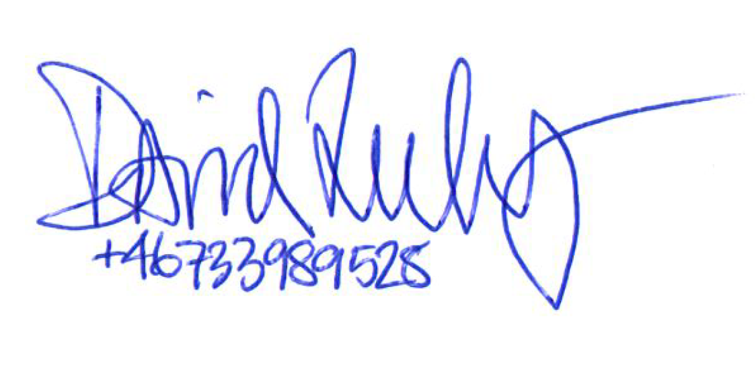

_________
Race officer

