29er
eurocup
2023

Notice to Competitors #1
2023-05-05; 17:00

Update to Supplementary Sailing Instructions 3.1 & 3.2

3.1 The 1st Rounding mark and the Gate bouys will be RED automatic (motorized bouys)

3.2 Upon a change of a leg, the replacement buoy will be a YELLOW CYLINDER

Other: The race committee will communicate on VHF channel 72.

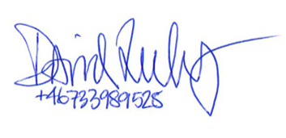

_________
Race officer

