 **Supplementary Sailing Instructions (SI)**

***Swedish Championship for*** ***Finn Dinghy***

**Date:** 12-14 September 2025

**Location:** Sätterholmsfjärden, Karlstad

**Level:** Röd

**Class:** Finnjolle

**Compitition:** Open class

**Organizer:** Karlstads Kappseglingsförening

**1. Race Office and Signal mast**

1.1 Race Office is located in Karlstads Kappseglingsförenings local.

1.2 Signals made ashore will be displayed on the flag pole outside the Race Office

1.3 When flag AP is displayed ashore, ’1 minute’ is replaced with ’not less than 60 minutes’ in RRS Race Signals.

**2. Time Program**

2.1

|  |  |  |
| --- | --- | --- |
| Day | Date | Planned time for first warning signal |
| Friday | 2025-09-12 | 10:55 |
| Saturday | 2025-09-14 | 09:55 |
| Sunday | 2025-09-14 | 09:55 |

2.2 No warning signal after 14:00 the 2024-09-14

**3 Marks**

3.1 Course: Yellow Cylinders

Start line: Orange flags

Finish line: Blue flags

3.2 When changing the course, the marks will be yellow cylinders.

**4 Time Limitations**

4.1 The time limit for the first boat to sail the course is 90 minutes.

4.2 A boat that does not finish within 25 minutes after the first boat has finished, will be scored Did Not Finish (DNF).

**5. Changes or suplementary information to Appendix S**

5.1 **The Course**

Windward-leeward with an offset will be sailed.

Start – 1 – 1a – 5 – 1 – 1a – 5 – Finish



5.2 **Change of the course**

If flag T is displayed in connection with the start, an extra loop shall be sailed.

**Date:** [ange datum och klockslag för fastställande]

**Some flags/signals**

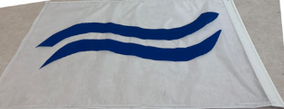 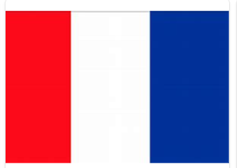

Class flag Finn T for 3 loops

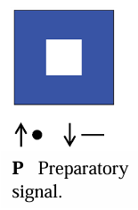 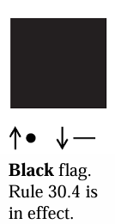 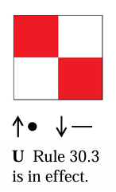 *Free pumping Restricted pumping*

