Sailing Instructions (SI)

Open Swedish Mastership

Dates: 26 august – 28 august

Location: Kalmar, Sweden

Boatclass: Finn dinghy, OK dinghy

Organizing authority: Sailing club Vikingarna (Segelsällskapet Vikingarna)

1. Rules

  - The event is governed by the rules as defined in The Racing Rules of Sailing (RRS).

2. Changes to the Sailing Instructions

2.1 Any change to the sailing instructions will be posted on the official notice board at the race office (also sailarena) before 08:00 on the day it will take effect.

2.2 Any change to the schedule of races will be posted by 20:00 on the day before it will take effect.

3. Signals made ashore

3.1 Signals made ashore will be displayed on the official flag pole in front of the race office.
3.2 When flag AP is displayed ashore, ’1 minute’ is replaced with ’not less than 60 minutes’ in RRS Race Signals.

4. The start

4.1 Friday, August 26th 09:30 Skipper's meeting, OBS NEW TIME
10:55 First warning signal of the day
3 races planned
No warning signal past 15:00

Saturday, August 27th 09:55 First warning signal of the day
3 races planned
No warning signal past 16:30
Sunday, August 28th 09:55 First warning signal of the day
2 races planned
No warning signal past 15:00

4.2 To alert boats that a new starting sequence is about to begin, the orange flag on the starting line will be displayed with a sound signal not less than five minutes before the warning signal.

4.3 A boat that does not start within five minutes after her starting signal will be scored Did Not Start (DNS) without a hearing. This changes RRS A5.1 and A5.2.

5. The course

5.1 The starting line is between a staff displaying an orange flag on the race committee vessel at the starboard end and an orange spar bouy on the port-end side.

5.2 The diagram below shows the course, the order in which marks are to be passed and the side of which each mark is to be left.

Finn dinghys’ course is to be sailed
Start, 1, 2, 3b, 2, 3b, Mål (Finnish).
The rounding marks are yellow cylinders. All marks are to be left to port.

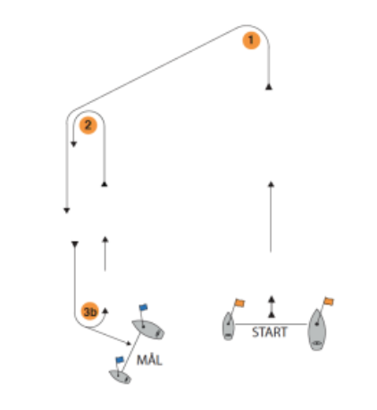

OK dinghys’ course is to be sailed
Start 1, 4, 1, 2, 3b, Mål (Finnish).

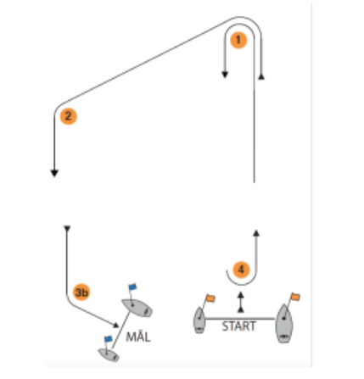

5.3 The finishing line is between a staff displaying a blue flag on a separate race committee vessel and a blue spar bouy.

5.4 The race committee will try to set the course so that a race will take approximately 45 minutes for the first boat.

5.5 The time limit for the first boat to sail the course is 90 minutes.

6. Protests and requests for hearings

6.1 Protests and request for hearings shall be filed at the race office within the protest time limit and comply with the requirements of RRS 61.2.

6.2 The protest time limit is 1 hour after the last boat finishes the last race of the day or the race committee signals no more racing today, whichever is later.

6.3 Notices will be posted no later than 30 minutes after the protest time limit to inform competitors of hearings in which they are parties or named as witnesses, including time and place for the hearing. Call for hearing may also be e-mailed to the parties.

Date: August 25th, 20:40

