Safetyplan SM OK- and fine dinghy, Kalmar 2022.
Safety instructions for all participants and officials
• All participants and officials must wear a life jacket when they are on or near the water
• First out on the water is always a safety boat, then sailing dinghies
• High preparedness to be able to act quickly in the event of an accident.
• that our sailboats stay within our designated area.
• A person in the water should generally be considered to be in danger or in need of assistance. It is therefore everyone's duty to offer help to people in the water and, if necessary, rescue them
• Always secure people first, then equipment and boats
• All officials have received a safety briefing where risks and measures have been reviewed
• All participating escort boats are part of the Safety Organization and are expected to assist all boats when necessary
CONTACT DETAILSR
RACING MANAGEMENT
Funktionärer | Namn | Kanal | Telefon
Competionsleader | Marianne Lehtonen | 77 | +4673-400 39 39
Sailingleader | Per-Olof Lindqvist | 77 | +4676-106 63 19
Security manager | Kristofer Svensson | 77 | +4670-549 57 74
AUTHORITIES CONCERNED AND OTHERS
Authority/others | Contactst |  | phone
Sea rescue | On-call rescue leader |  | 112
Healthcare information |  |  | 1177

Special instructions
All official boats must be equipped with
1. Telephone and telephone directory
2. Medical equipment
3. Safety kit (knife and nippers)
4. Sailing regulations with course description
5. List of participants
6. Crew list and security plan
All officials must wear a yellow vest. The safety boat should be the last to enter port. In the event of an accident, call 112 or call "Sweden Rescue" on VHF channel 16. Then contact the competition management
Emergency, urgent event
Larma Räddningstjänsten via telefon 112 eller anropa ”Sweden Rescue” på VHF kanal 16. Den som observerar ett nödläge skall direkt larma Sjöräddningen (Sweden Rescue) eller Räddningstjänst (SOS Alarm). Larm skall av tidsskäl inte ske via tävlingsledningen. Däremot skall tävlingsledningen och säkerhetsansvarig informeras så snart som möjligt.
Vid nödläge skall insatserna i första hand inriktas på att rädda personer. Uppsamlingsplats i land är klubbhuset Stensö fiskeläger. Alla som finns tillgängliga och alla båtar har skyldighet att hjälpa till vid ett nödläge.
Uppsamlingsplats till havs är Start- & Målfartyg när/om det blir många som har ramlat i vattnet.
In case of serious personal injury
1. Treat the casualty (in BBS order: Breathing, Bleeding, shock/trauma)
2. Call 112 or call "Sweden Rescue" on VHF channel 16
3. Inform the security officer (mobile or via VHF).

Course-laying boats and judges' boats become safety boats by decision of the sailing director. Other boats can be given information from the safety officer or other e.g. Swedish rescue
Approximate racearea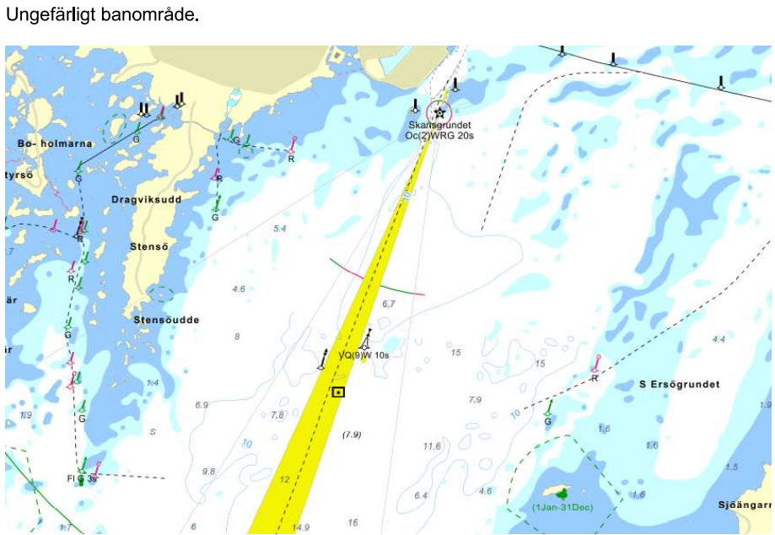

Planned first start Friday 26 August at 11.00
Planned first start Saturday 27 August, at 10.00
Planned first start Sunday 28 August at 10.00

