Notice to Competitors #2
2022-05-07; 08:30

The race committee will communicate on VHF channel 72.
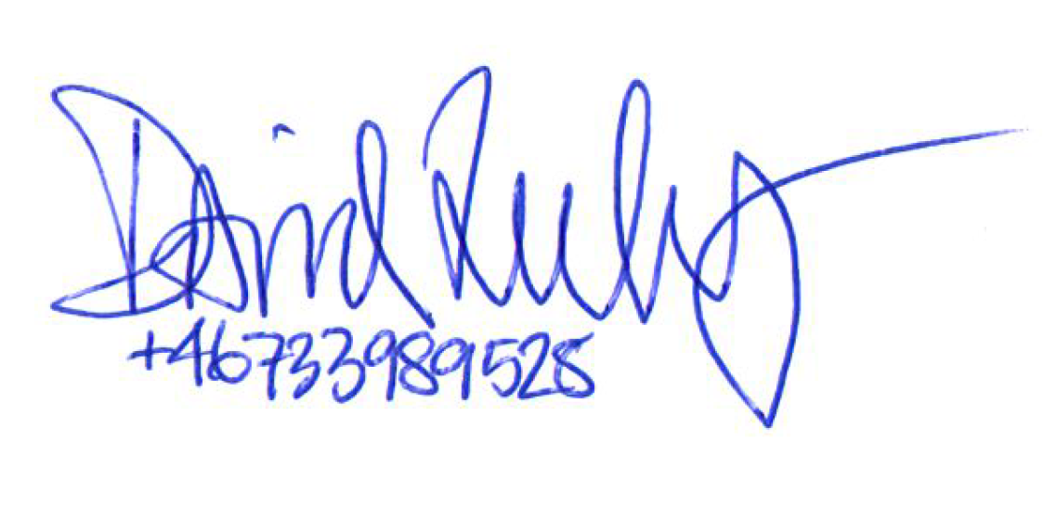

_________
Race officer

