Notice to Competitors #1
2022-05-06; 18:00

Update to Supplementary Sailing Instructions 3.2

Upon a change of a leg, the replacement buoy will be a RED TETRA (was a blue cylinder)
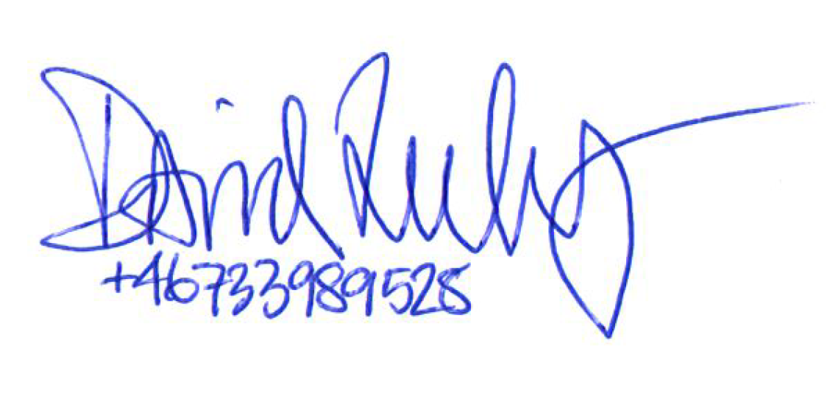

_________
Race officer

