Information on arrival
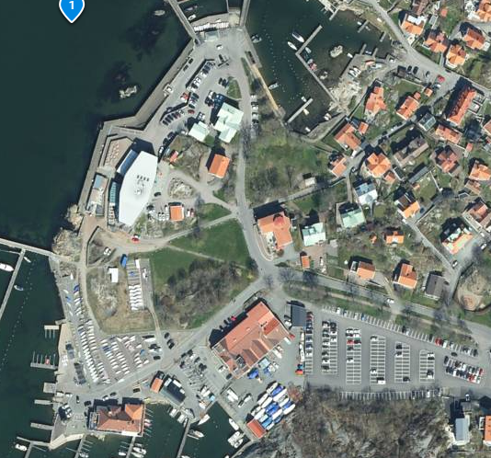
Parking
Car parking marked BLUE to the left when arriving GKSS.
Launching coachboats
In the harbour marked YELLOW will be open on Friday and Sunday. On Saturday we ask you use the facilities at Hinsholmens småbåtshamn.
Mooring coachboats
Area marked LIGHT BLUE
Trailerparking
Areas marked GREEN.
Dinghy areas
Areas marked RED.
Launching dinghies
All dinghies use the PINK area in the harbour. Windfoil use the ORANGE area.

