Open OK-Dinghy Nordic
Championship 2022
June 10-12
Varberg, Sweden

SAILING INSTRUCTIONS

The notation ’DP’ in a rule in the SI means that the penalty for a breach of the rule may, at the discretion of the Protest Committee, be less than disqualification.

- RULES
  - The regatta will be governed by the rules defined in the Racing Rules of Sailing (RRS) with the prescriptions of the Nordic Sailing Federation.

  - The rules for Nordic Championships of the Nordic Sailing Federation will apply.

  - The following Racing Rules are changed:

- RRS A4 and A5 are changed by SI 10.3
- RRS 35, A4 and A5 are changed by SI 14.2
- RRS 40 is changed by SI 17.2 and NoR 12

  - If there is a conflict between languages the English text will take precedence.

- NOTICES TO COMPETITORS
Notices to competitors will be posted on the Official Notice Board at the club house and, when possible, as an extra service at https://www.sailarena.com/sv/se/club/vass/ok-dinghy-nordic-championship-2022/

- CHANGES TO THE SAILING INSTRUCTIONS
Any change to the Sailing Instructions will be posted before 08:00 on the day it will take effect, except that any change to the schedule of races will be posted not later than 20:00 on the day before it will take effect.

- SIGNALS MADE ASHORE
  - Signals made ashore will be displayed at the flag pole at the club house.
  - When flag AP is displayed ashore, ’1 minute’ is replaced with ’not less than 60 minutes’ in the race signal AP.

- SCHEDULE OF RACES
  - Six (6) races are scheduled

Date | Number of Races | First warning signal
Saturday | 3 | 10:55
Sunday | 3 | 09:55

  - To alert boats that a race or a sequence of races will begin soon, the orange starting line flag will be displayed with one sound at least five minutes before a warning signal is made.

  - On the last scheduled day of racing no warning signal will be made later than 14:55.

- CLASS FLAGS
Class flag will be flag E.

- RACING AREA
The racing area will be on the waters SW of Getterön Harbour (See Attachment A).

- THE COURSES
  - The diagram in Attachment B shows the course, including the approximate angles between the legs, the order in which marks are to be passed, and on which side each mark is to be left.

  - No later than the warning signal, the Race Committee will display the approximate compass bearing to mark 1.

- MARKS
  - Marks are described in Attachment B.

  - A race committee vessel signaling a change of a leg of the course is a mark as provided in SI 11.2.

- THE START
  - Races will be started by using RRS 26.

  - The starting line will be between staffs displaying orange flags on the starting marks.

  - A boat that does not start within 4 minutes after her starting signal will be scored Did Not Start (DNF) without a hearing. This changes RRS A4 and A5.

- CHANGE OF THE NEXT LEG OF THE COURSE
  - To change the next leg of the course, the Race Committee will lay a new mark, an orange cylinder, but there will be no offset mark (1a), (or move the finishing line) and remove the original mark as soon as practicable. When in a subsequent change a new mark is replaced, it will be replaced by an original mark.

  - Except at a gate, boats shall pass between the race committee vessel signaling the change of the next leg and the nearby mark, leaving the mark to port and the race committee vessel to starboard.

- THE FINISH
  - The finishing line will be between staffs displaying blue flags on the finishing marks.

- PENALTY SYSTEM
  - Appendix P will apply.
  - RRS P2.3 will not apply and RRS P2.2 is changed so that it will apply to any penalty after the first one.

- TIME LIMITS AND TARGET TIMES
  - Time limits and target times are as follows:
Class Time limit Mark 1 time limit Target time
OK-dinghy 100 minutes 30 minutes 60 minutes

If no boat has passed Mark 1 within the Mark 1 time limit, the race will be abandoned.

  - Boats failing to finish within 15 minutes after the first boat sails the course and finishes will be scored Did Not Finish (DNF) without a hearing. This changes RRS 35, A4 and A5.

- PROTESTS AND REQUESTS FOR REDRESS
  - Appendix T, arbitration, will be used.

  - Protest forms are available at the Race Office. Protests and requests for redress or reopening shall be delivered there within the appropriate time limit.

  - The protest time limit is 60 minutes after the last boat has finished the last race of the day, or the race committee signals no more racing today, whichever is later.

  - Notices will be posted no later than 30 minutes after the protest time limit to inform competitors of hearings in which they are parties or named as witnesses. Hearings will be held in the protest room located in the club house.

  - A list of boats that, under SI 13, have been penalized for breaking RRS 42 will be posted.

  - On the last scheduled day of racing a request for redress based on a protest committee decision shall be delivered no later than 30 minutes after the decision was posted. This changes RRS 62.2.

- SCORING
  - Three (3) races are required to be completed to constitute a series.

  - (a) When fewer than four (4) races have been completed, a boat’s series score will be the total of her race scores.

(b) When four (4) or more races have been completed, a boat’s score will be the total of her race scores excluding her worst race score.

- SAFETY REGULATIONS
  - A boat that retires from a race shall notify the Race Committee as soon as possible. [DP].

  - Competitors shall when afloat wear personal flotation devices. This rule does not apply to short-term replacement or adjustment of clothing or personal equipment, or when competitors are in the harbour. Wet suits and dry suits are not personal flotation devices. This changes RRS 40. [DP].

- REPLACEMENT OF CREW OR EQUIPMENT
Substitution of damaged or lost equipment will not be allowed unless authorized by the Race Committee. Requests for substitution shall be made to the committee at the first reasonable opportunity. [DP].

- EQUIPMENT AND MEASUREMENT CHECKS
On the water, a boat can be instructed by a member of the Race Committee or the Technical Committee to proceed immediately to a designated area for inspection. Ashore, equipment may be inspected or measured at any time during the regatta.

20 OFFICIAL BOATS
Official boats will be marked as follows:
Protest committee boats are flying flags with ’Jury’ or ’J’.

- SUPPORT BOATS
21.1 Team leaders, coaches and other support boats shall stay more than 50 metres from any racing boat and 50 metres from the starting or finishing lines. [DP].

21.2 Support and coach boats shall display national identification (national flag or country letters). [DP].

- TRASH DISPOSAL
Trash may be placed aboard support or official boats.

23 RADIO COMMUNICATION
Except in emergency, a boat that is racing shall not make voice or data transmission and shall not receive voice or data communication that is not available to all boats.

Attachment A

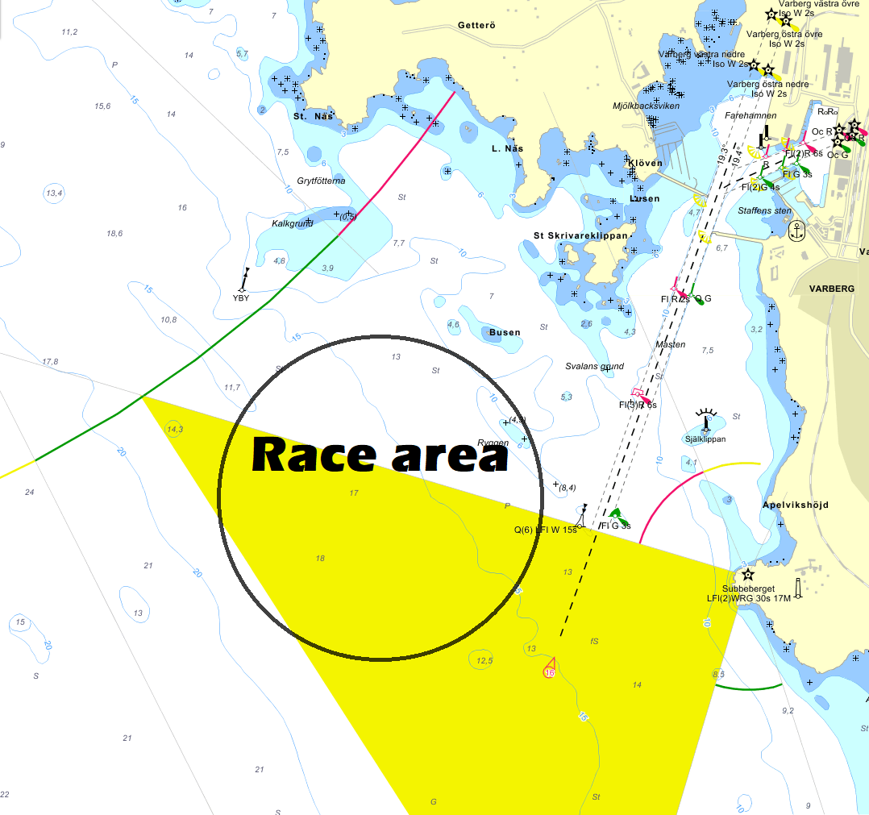
Church tower clear of Castle walls
Keep south of this line

Attachment B

Windward-Leeward Course

Start – 1 – 1a – 4s/4p – 1 – 1a – 5 - Finish
NOTE: ON LEG 1A (OR 1 AFTER A COURSE CHANGE)– 5, A BOAT IS NOT ALLOWED TO SAIL OVER THE FINISHING LINE OR ITS EXTENSION
Marks:
1, 4s and 4p: Yellow cylinders
1a: white buoy
5: orange cylinder
New mark at first course change – Orange cylinder (See SI 11.1)
Starting line: RC Boats with orange flags
Finishing line: RC Boats with blue flags

