Danmarks Idrætsforbunds
Danmarksmesterskab Finn
Open Swedish Finn Class Championship
Scandinavian Finn Cup
August 20-23, 2026
Varberg, Sweden
The Organizing Authority is Varbergs Segelsällskap in conjunction with the Swedish, Danish and Norwegian Finn classes.

SAILING INSTRUCTIONS (SIs)

- RULES
  - The regatta is governed by the rules as defined in the Racing Rules of Sailing for 2025-2028 (RRS).
  - The IFA Class Rules will apply.

- CHANGES TO SAILING INSTRUCTIONS
  - Any change to the sailing instructions will be posted before 0900 on the day it will take effect, except on Friday when a change in the sailing instructions will be posted not later than 1130. Any change to the schedule of races will be posted not later than 2000 on the day before it will take effect.

- COMMUNICATIONS WITH COMPETITORS
  - Notices to competitors will be posted on the official notice board at the club house. As a service to the sailors a WhatsApp message will be sent out with the message posted on the official notice board.
  - The race office is in the club house of Varbergs Segelsällskap

- CODE OF CONDUCT
  - [DP] Competitors and support persons shall comply with reasonable requests from race officials.
  - [DP] Competitors and support persons shall place advertising provided by the organizing authority with care, seamanship, in accordance with any instructions for its use and without interfering with its functionality.

- SIGNALS MADE ASHORE
  - Signals made ashore will be displayed at the yacht club’s signal mast.
  - When flag AP is displayed ashore, ‘1 minute’ is replaced with ‘not less than 60 minutes’ in Race Signals AP.

- SCHEDULE OF RACES
  - The regatta will consist of up to 9 races.
  - Dates of racing and number of races:
Warning Signal for the Number of
Date 1st race of the day races planned
22/8 14:00 2-3 races
23/8 10:30 3-4 races
24/8 10:30 3 races

  - To alert boats that a race will begin soon, the orange starting line flag will be displayed with one sound at least five minutes before a warning signal is made.
  - On the last scheduled day of racing no warning signal will be made after 15:00.

- CLASS FLAGS
  - The Class flag is flag D.

- RACING AREA
  - The racing area is located SW of the Marina as indicated in Attachment B.

- COURSES
  - The diagrams in SI Attachment A show the courses, including the approximate angles between legs, the order in which marks are to be passed, and the side on which each mark is to be left.

- MARKS
  - Marks are described in Attachment A.

- OBSTRUCTIONS
  - No obstructions in the racing area.

- THE START
  - Races will be started using RRS 26 with the warning signal made 5 minutes before the starting signal.
  - The starting line is between a staff displaying an orange flag on the signal vessel at the starboard end and a staff displaying an orange flag at the port-end starting mark.
  - A boat that does not start within 4 minutes after starting signal will be scored Did Not Start (DNS) without a hearing. This changes RRS A5.

- SHORTENING AND CHANGE OF THE NEXT LEG OF THE COURSE
  - To change the next leg of the course, the race committee will move the mark (or move the finishing line). At a course change the offset mark (Mark 1B) will not be used.
  - RRS 33 is changed, so when the next leg of the course is changed, displaying of signal flag C and giving repeated sound signals, is sufficient signalling.
  - A mark can be attached to the stern of the race committee signal boat. This mark is permanent and therefore part of that boat.

- THE FINISH
  - The finishing line is between a staff displaying a blue flag on the finishing mark at the starboard end and the course side of the port end finishing mark.

- PENALTY SYSTEM
  - RRS Appendix P applies.
  - RRS P2.3 does not apply and RRS P2.2 is changed so that it applies to any penalty after the first one.

- TIME LIMITS AND TARGET TIMES
  - The Mark 1 Time Limit, Race Time Limit (see RRS 35), and the Finishing Window are shown in the table below.
Mark 1 Time Limit | Race Time Limit | Finishing Window | Target Time
30 minutes | 90 minutes | 15 minutes | 45 minutes

  - If no boat has passed the first mark within the Mark 1 Time Limit, the race will be abandoned.
  - The Finishing Window is the time for boats to finish after the first boat sails the course and finishes. Boats failing to finish within the Finishing Window, and not subsequently retiring, penalized, or given redress, will be scored Time Limit Expired (TLE) without a hearing. A boat scored TLE shall be scored points for the finishing place one more than the points scored by the last boat that finished within the Finishing Window. This changes RRS 35, A5.1, A5.2 and A10.
  - Failure to meet the Target Time will not be grounds for redress. This changes RRS 62.1(a).

- HEARING REQUESTS
  - The protest time limit is 60 minutes after the last boat finishes the last race of the day or the race committee signals no more racing today, whichever is later. The time will be posted on the official notice board.
  - Hearing request forms are available from the race office.
  - Notices will be posted no later than 30 minutes after the protest time limit to inform competitors of hearings in which they are parties or named as witnesses. Hearings will be held in the protest room, located in the clubhouse of Varbergs Segelsällskap, beginning at the time posted.
  - Appendix T1 will be used.
  - On the last scheduled day of racing a request for reopening a hearing shall be delivered within the protest time limit if the requesting party was informed of the decision on the previous day. no later than 15 minutes after the requesting party was informed of the decision on that day. This changes rule 63,7.
  - On the last scheduled day of racing a request for redress based on a protest committee decision shall be delivered no later than 15 minutes after the decision was posted. This changes rule 62.2.

- SCORING
  - 3 races are required to be completed to constitute a series.
  - At least four races must be completed to gain official Danish Championship status.
  - (a) When fewer than 5 races have been completed, a boat’s series score is the total of her race scores.
(b) When 5 or more races have been completed, a boat’s series score is the total of her race scores excluding her worst score.
  - Rule A5.3 applies.

- SAFETY REGULATIONS
  - [DP] A boat that retires from a race shall notify the race committee at the first reasonable opportunity.
  - [DP] A boat shall sign out before leaving the harbour and sign in before end of protest time. Sign out/sign in lists will be available at the race office.

- REPLACEMENTS OF CREW OR EQUIPMENT
  - [DP] Substitution of damaged or lost equipment is not allowed unless authorized by the race committee Requests for substitution shall be made to the committee at the first reasonable opportunity, which may be after the race.

- EQUIPMENT AND MEASUREMENT CHECKS
  - A boat or equipment may be inspected at any time for compliance with the class rules, notice of race and sailing instructions.
  - [DP] When instructed by a race official on the water, a boat shall proceed to a designated area for inspection.

- OFFICIAL VESSELS
  - Official vessels will be identified with the pennants from Varbergs Segelsällskap.

- [DP] SUPPORT TEAMS
  - Team leaders, coaches and other support persons shall stay outside areas and at least 50 meters from any racing boat, where boats are racing from the time of the preparatory signal for the first start until all boats have finished or retired or the race committee signals a postponement, general recall, or abandonment.
  - Support person vessels shall be identified with National Letters or National flag.

- TRASH DISPOSAL
  - Trash may be placed aboard official vessels.

- BERTHING
  - [DP] Boats shall be kept in their assigned places while in the boat park.

- PRIZES
  - The perpetual trophies will be awarded to the winner of the Danish National Championship, and to the winner of the Open Swedish Finn Class Championship
  - The Organizing Authority will provide prizes for the different disciplines of this regatta.
  - Dansk Sejlunion Prizes (medals) will be given to the best three (3) Danish boats.
  - There will be awarded a “Danish Veteran Trophy” to the best participant over 60 years.

- INSURANCES
27.1Each participating boat shall be insured with valid third-party liability insurance.

Event chairman: Olof Bengtsson
Principal Race Officer: HP Hylander, (IRO)
Race officer: Jan H. Madsen, (NRO)
Protest committee chairman: Martin Corin, (NJ)
RRS 42 judge(s) : Martin Corin, (NJ) and Ulf Carlsson, (NJ)

ATTACHMENT A
The Course:
Flag no1: Start – 1 – 1a – 2 – 3 – 2 - 3 – 5 - Finish.
Flag no2: Start – 1 – 1a – 4 – 1 – 1a – 2 – 3 – 5 - Finish

Marks 1 & 4: Yellow inflated cylindric buoys.
Mark 1a: Orange buoy
Marks 2 & 3: Yellow inflated triangular buoys.
Mark 5: Orange inflated cylindric buoy.
Starting line: Between orange flags. The starting marks will be the Race Committee vessel in starboard end and a pin end boat at port end.
The finishing marks will be the race committee boat in one end and a buoy in the other end. Both ends will display blue flags.

A mark can be attached to the stern of the race committee signal boat. This mark is permanent and therefore part of that boat.

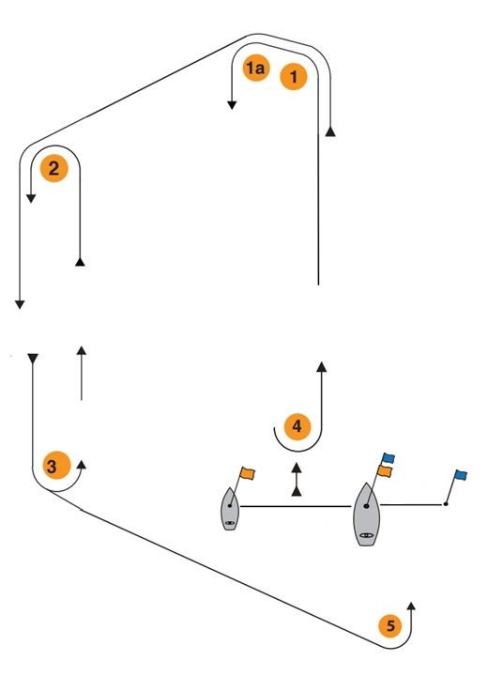
ATTACHMENT B

