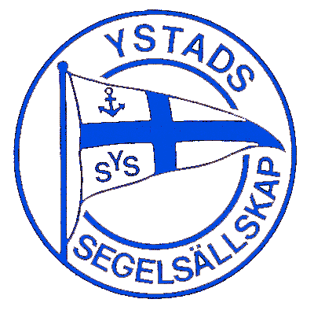

Ystad Jubilee Regatta 2022

RC1 Changes in Schedule
August 11, 2022
- Skipper’s briefing at 10:00.
- There will be no Practice Race
Posted 2022-08-10 at 19:20.

